AZURE NETWORK WATCHER
Connection Troubleshooting Playbook
PROJECT DOCUMENTATION
A standardized Azure-based workflow for diagnosing network connectivity failures, analyzing root causes, and generating troubleshooting results.
Project | Azure Network Watcher Connection Troubleshooting Playbook
Team | T179
Domain | Cloud Computing / Azure Networking
Document Type | Project Architecture and Technical Documentation

1. Abstract
The Azure Network Watcher Connection Troubleshooting Playbook is designed to automate and standardize the diagnosis of network connectivity problems in Microsoft Azure. The project combines Azure Network Watcher with an automation layer, Azure networking components, monitoring, logging, and reporting services. A user or administrator supplies source and destination details, protocol, and port information through a web dashboard or Azure Portal. The playbook validates the request, invokes Azure Network Watcher Connection Troubleshoot, analyzes the diagnostic result together with relevant network configuration, identifies a likely failure point, and produces a concise troubleshooting result.
The approach addresses a common operational challenge: connectivity failures may originate from Network Security Groups (NSGs), route tables, blocked ports, firewall rules, network interfaces, or other network configuration issues. By following a repeatable workflow, the project supports consistent troubleshooting, clearer root-cause analysis, diagnostic history, and recommended corrective actions.

2. Problem Statement
In Microsoft Azure cloud environments, network connectivity issues can occur due to incorrect Network Security Group rules, routing configurations, blocked ports, firewall settings, or misconfigured network resources. Identifying the exact cause can be difficult and time-consuming, especially when multiple Azure networking components are involved.
Traditional troubleshooting may require administrators to manually inspect several configurations and diagnostic tools. This can result in inconsistent troubleshooting procedures and longer resolution times. Therefore, there is a need for a systematic and easy-to-follow troubleshooting playbook that uses Azure Network Watcher to diagnose connectivity problems, identify their root causes, and provide appropriate corrective actions.
The proposed playbook addresses this need by providing a standardized step-by-step procedure for analyzing and resolving common Azure network connectivity issues.

3. Project Objectives
- Create a repeatable workflow for Azure network connectivity troubleshooting.
- Accept source, destination, protocol, and port parameters for a connection test.
- Validate the supplied troubleshooting inputs before executing diagnostics.
- Use Azure Network Watcher Connection Troubleshoot as the primary diagnostic operation.
- Analyze relevant NSG, route table, firewall, NIC, VNet, and VM configuration.
- Identify the likely failure point using available diagnostic evidence.
- Generate recommended corrective actions for administrators.
- Store diagnostic and operational information for investigation and historical reference.
- Produce a clear troubleshooting report and support notifications when configured.

4. Project Overview
The project follows a layered service architecture. The user interface collects troubleshooting parameters, the automation layer starts and coordinates the playbook, Azure Network Watcher performs the primary connectivity diagnostics, Azure networking services provide configuration context, and Azure Monitor and Log Analytics support monitoring, storage, analysis, and reporting.
At the endpoint level, a source virtual machine (VM-A) is tested against a destination virtual machine (VM-B). The playbook examines the connection path and relevant network controls such as NSGs, route tables, and Azure Firewall or other security devices. The resulting diagnostic information is then analyzed and presented as connectivity status, root-cause information, recommended actions, and supporting logs.

5. Project Architecture
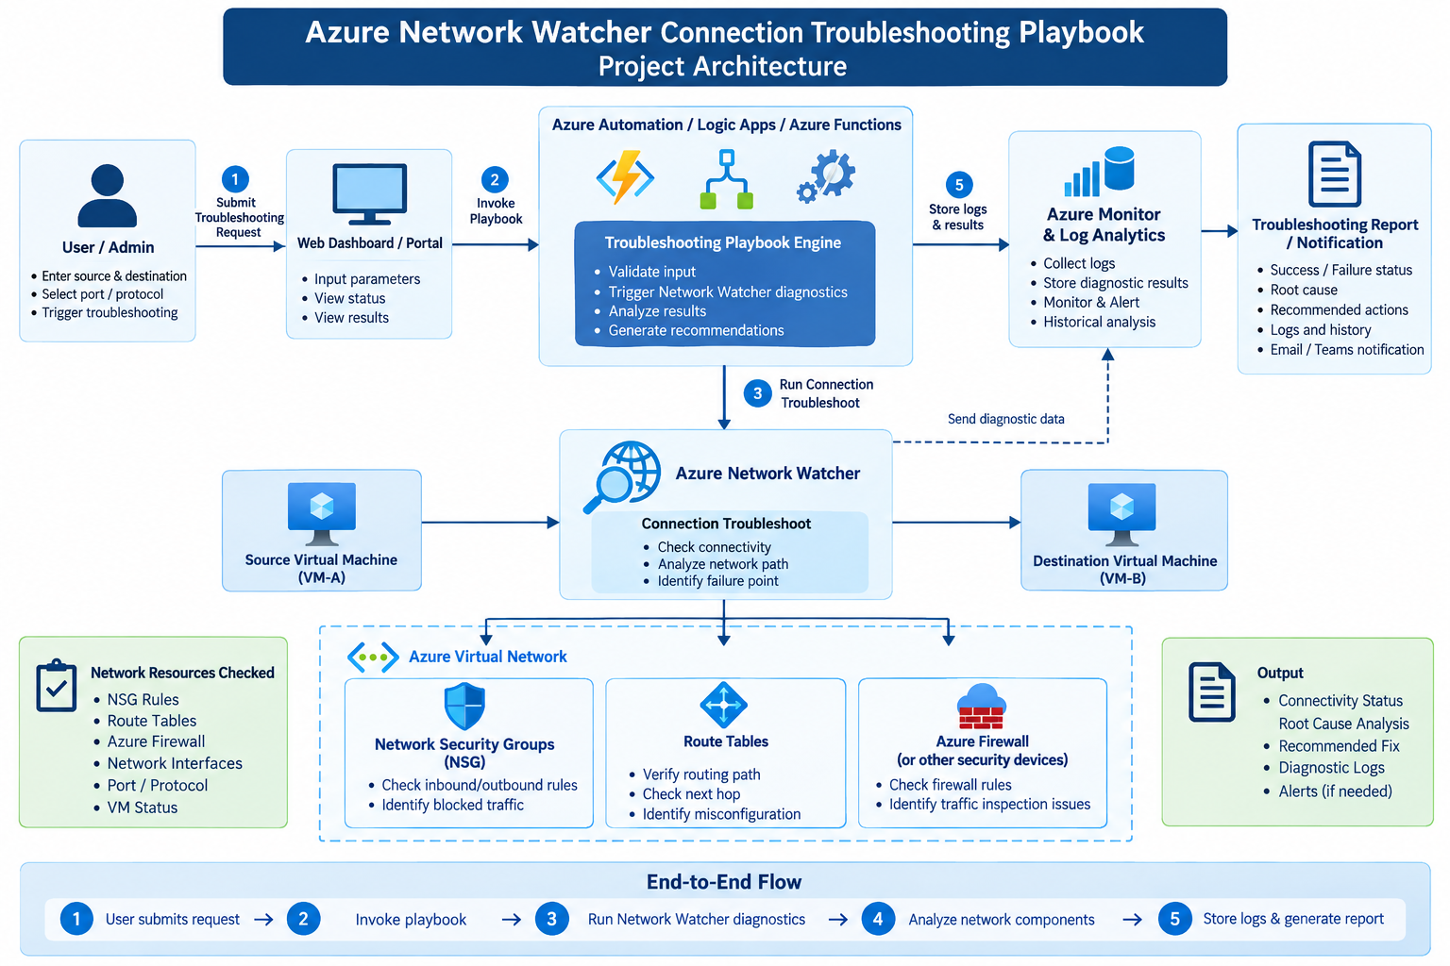
Figure 1. Azure Network Watcher Connection Troubleshooting Playbook – Project Architecture
The architecture diagram shows the end-to-end flow: the User/Admin submits a troubleshooting request through the Web Dashboard or Azure Portal; the automation layer invokes the playbook; the playbook runs Network Watcher Connection Troubleshoot; diagnostic data is analyzed with the relevant virtual network components; results are stored in Azure Monitor and Log Analytics; and a troubleshooting report or notification is generated.
The diagram also identifies the principal network resources checked during analysis: Network Security Groups, Route Tables, and Azure Firewall or other security devices. The output includes connectivity status, root-cause analysis, recommended fixes, diagnostic logs, and alerts when required.

6. End-to-End Architecture Flow
Stage | Description
1. User Request | The user/admin enters the source, destination, protocol, and port and submits the troubleshooting request.
2. Invoke Playbook | The Web Dashboard or Azure Portal passes the request to Azure Automation, Logic Apps, or Azure Functions.
3. Run Network Diagnostics | The automation layer validates the request and invokes Azure Network Watcher Connection Troubleshoot.
4. Analyze Network Components | The diagnostic result is evaluated together with relevant VM, NIC, VNet, NSG, route table, and firewall configuration.
5. Store and Report | Diagnostic and operational information is stored in Azure Monitor and/or Log Analytics, followed by report generation or notification.

7. Azure Services and Components
Service / Component | Role | Purpose in Project
Azure Network Watcher | Core network diagnostic service | Runs Connection Troubleshoot and helps determine whether traffic can reach the destination and where connectivity is failing.
Azure Virtual Network (VNet) | Network infrastructure | Provides the logical network environment containing subnets, NICs, and virtual machines.
Network Security Group (NSG) | Traffic security | Controls inbound and outbound traffic using security rules; relevant rules are checked for blocked connections.
Route Tables / User Defined Routes | Traffic routing | Controls traffic paths and helps identify incorrect or missing routes.
Azure Firewall | Network security | Provides centralized traffic filtering; relevant firewall rules can be examined for connectivity failures.
Azure Virtual Machines | Source and destination endpoints | Act as the systems used for connection tests.
Azure Network Interfaces (NICs) | VM network connectivity | Connect virtual machines to the VNet and provide network-level configuration that can affect connectivity.
Azure Automation / Logic Apps / Azure Functions | Automation layer | Triggers and coordinates the workflow, validates inputs, calls diagnostics, and processes results.
Azure Monitor | Monitoring and alerting | Monitors the environment and supports alerts for important network or operational events.
Log Analytics Workspace | Centralized logging | Stores diagnostic and operational data for investigation, history, and reporting.

8. Detailed Service Responsibilities

Azure Network Watcher
- Performs the primary connection troubleshooting operation.
- Checks connectivity between a source and destination.
- Helps identify the point or component associated with a connectivity failure.
- Provides diagnostic information for playbook processing.

Azure Automation / Logic Apps / Azure Functions
- Receives the troubleshooting request.
- Validates source, destination, protocol, and port parameters.
- Triggers Network Watcher diagnostics.
- Processes the diagnostic response.
- Applies troubleshooting logic and prepares the final result.

Virtual Network and Network Components
- VNet provides the overall network boundary.
- Subnets organize resources within the VNet.
- NICs provide VM-level network connectivity.
- NSGs control permitted and denied traffic.
- Route tables determine the traffic path.
- Azure Firewall may inspect and filter traffic.

Azure Monitor and Log Analytics
- Collect relevant monitoring and diagnostic information.
- Maintain troubleshooting history.
- Support analysis of repeated failures.
- Can be integrated with alerts and operational dashboards.

Reporting and Notification
- Displays connection status.
- Reports the suspected or identified failure point.
- Provides recommended corrective actions.
- Records logs and troubleshooting history.
- Can notify administrators when configured.

9. Troubleshooting Workflow
- Request: The administrator enters the source VM, destination VM or IP, protocol, and port.
- Validation: The automation layer validates the supplied parameters and confirms that the required Azure resources can be referenced.
- Diagnostic Test: Azure Network Watcher Connection Troubleshoot is invoked.
- Network Analysis: The result is analyzed together with relevant NSG, routing, firewall, NIC, and VM configuration.
- Root-Cause Identification: The playbook identifies the likely failure point based on the available diagnostic evidence.
- Recommendation: The system generates a recommended corrective action, such as reviewing a blocked NSG rule or routing configuration.
- Logging: The diagnostic result and relevant operational information are stored in Azure Monitor and/or Log Analytics.
- Reporting: A concise troubleshooting report is produced for the administrator.

10. Network Resources Checked During Troubleshooting
Resource | Checks Performed
Network Security Groups (NSG) | Check inbound/outbound rules and identify traffic that may be blocked.
Route Tables | Verify routing path, check next hop, and identify routing misconfiguration.
Azure Firewall / Security Devices | Check firewall rules and identify traffic inspection or filtering issues.
Network Interfaces | Review VM-level network configuration that may affect connectivity.
Virtual Machines | Confirm source/destination endpoints and VM status relevant to the connection test.
Virtual Network / Subnets | Provide the network context and topology in which the endpoints operate.

11. Use Cases
Use Case | Description
Virtual Machine Connectivity Troubleshooting | Diagnose connectivity problems between two Azure VMs. Example: a user cannot connect from one VM to another using a specific port. The playbook uses Connection Troubleshoot and relevant diagnostics to determine whether traffic is reaching the destination and whether an NSG or routing rule is blocking it.
Blocked Port Detection | Identify whether a required network port is blocked. Example: an application on port 8080 cannot be accessed from another VM. The playbook checks the port and examines NSG and firewall rules for a blocking condition.
Network Security Group Troubleshooting | Identify connectivity problems caused by incorrect inbound or outbound NSG rules, such as a web server that is running but cannot be accessed.
Routing Problem Identification | Identify incorrect or missing routes that prevent traffic from reaching its destination, such as traffic between two subnets that fails to reach the destination VM.
Application Connectivity Troubleshooting | Troubleshoot connectivity between an application and dependent services by checking source, destination, protocol, port, NSGs, routes, and firewall configuration.
Network Topology Analysis | Understand how Azure networking resources are connected using Network Watcher Network Topology.
Root Cause Identification | Determine the likely cause of a connectivity failure when it is unclear whether the problem is related to an NSG, route, port, or firewall.
Post-Fix Connectivity Verification | Run the connection test again after a configuration change and confirm whether the required connection is successful.
Incident Documentation | Maintain a consistent record of symptoms, diagnostic steps, root cause, corrective action, and verification results.
Standardized Troubleshooting Workflow | Provide administrators with a common procedure from problem identification through diagnosis, resolution, and verification.

12. Example Project Scenario
Suppose VM-A must connect to VM-B using TCP port 443. The user starts the playbook and provides VM-A as the source, VM-B as the destination, TCP as the protocol, and 443 as the port. The automation layer validates the request and invokes Azure Network Watcher.
If the connection fails, the playbook examines the diagnostic result together with the relevant network configuration. For example, if an NSG rule denies the traffic, the report identifies the NSG rule as a possible cause and recommends reviewing the rule. After a corrective change is applied, the connection test can be run again to verify whether connectivity has been restored.

13. Inputs and Expected Outputs
Inputs | Expected Outputs
Source VM, destination VM/IP, protocol, port, and required Azure resource references. | Connectivity status; source and destination details; protocol and port tested; diagnostic findings; probable failure point or affected network component; recommended troubleshooting action; diagnostic logs and execution history; optional alert or notification.

14. Security Considerations
- Use Azure role-based access control (RBAC) and grant only the permissions required by the playbook.
- Protect credentials, secrets, and automation identities.
- Avoid exposing sensitive network configuration in user-facing reports.
- Record administrative actions and troubleshooting executions for auditing.
- Use secure communication and follow Azure security best practices.

15. Project Benefits
- Standardizes the troubleshooting process across administrators.
- Reduces dependence on manual inspection of multiple Azure network components.
- Provides a structured method for identifying likely failure points.
- Combines diagnostics with network configuration context.
- Maintains diagnostic history for investigation and recurring incidents.
- Produces clear troubleshooting information and recommended actions.
- Supports monitoring, alerting, and reporting through Azure Monitor and Log Analytics.

16. Scope and Limitations
The playbook is centered on Azure network connectivity diagnosis using the services and components defined in the project architecture. The documented workflow identifies likely failure points from available diagnostic evidence and relevant network configuration; it does not imply that every connectivity incident can be resolved automatically. Corrective actions may require administrator review and configuration changes, followed by post-fix connectivity verification.

17. Conclusion
The Azure Network Watcher Connection Troubleshooting Playbook provides a structured approach to diagnosing Azure network connectivity problems. Azure Network Watcher acts as the core diagnostic service, while Azure networking, automation, monitoring, logging, and reporting services work together to create a repeatable troubleshooting process.
The resulting workflow moves from request and validation through diagnostics, network-component analysis, root-cause identification, recommendation, logging, and reporting. This architecture supports consistent investigation of common issues involving NSGs, routing, ports, firewalls, NICs, VMs, and related Azure network resources.

18. Project Team
TEAM T179
Student ID | Name
2400031522 | Kommareddy Lakshmi Naga Sai Swarup
2400031514 | Pasupuleti Yamini DhanaLakshmi
2400031673 | Kiran Kumar
2400031443 | Guru sri charan

19. Source Basis
This documentation consolidates the uploaded project abstract, project services document, and the supplied project architecture diagram. The terminology and workflow have been retained from those project materials while organizing the content into a single presentation-ready document.

